Valley Credit Union Q4 2024 IT Dashboard

Active Users: 67
Total Computers: 78
- Windows 10 pro: 48
- Windows 11 pro: 30
Servers: 5
- Windows Server 2019 Standard: 3
- Windows Server 2012 R2 Standard: 2

Microsoft License Status:
- Microsoft Business 365 Business Premium: 76/78
- Microsoft Business 365 Business Standard: 30/30
- Microsoft Teams Phone with calling plan: 82/84

Microsoft Defender Licenses Status:
- Microsoft Defender for Business: 78
Microsoft Email Volume in the Last 30 days:
- Sent: 5,377
- Received: 23,370

PRINTERS - 21
- All printers are managed by Xtra Documents

Patches applied on Endpoints in Q4:
- 100 % Patches applied on 73 endpoints including servers.
- 80 Percent Patches applied at 9 endpoints.

NIST update: MCS minutes
- See attached NIST tracker and MCS Minutes

MS Defender Score:
Overall Score from Microsoft defender is 45.11% which is higher than an organization of a similar size.
- 0 threats found in the last 30 days. 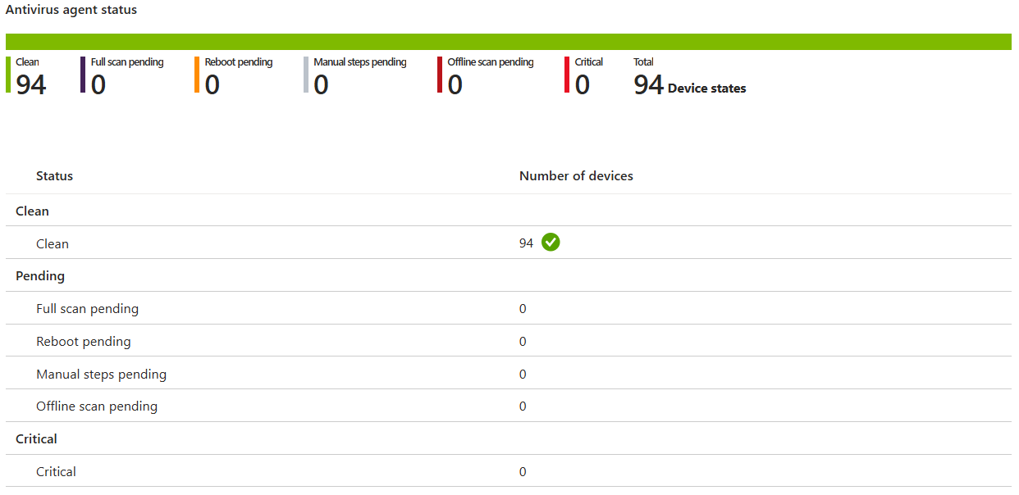

Overall Secure Score:
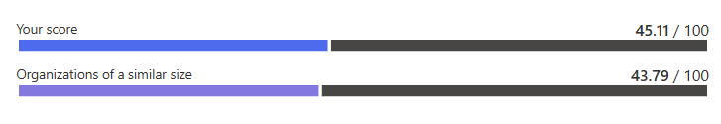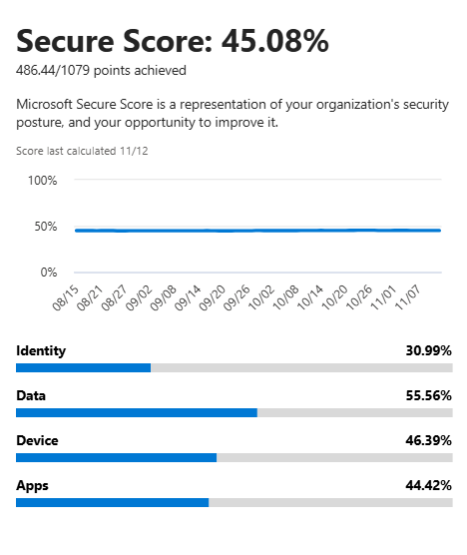


Beauceron Score: 616
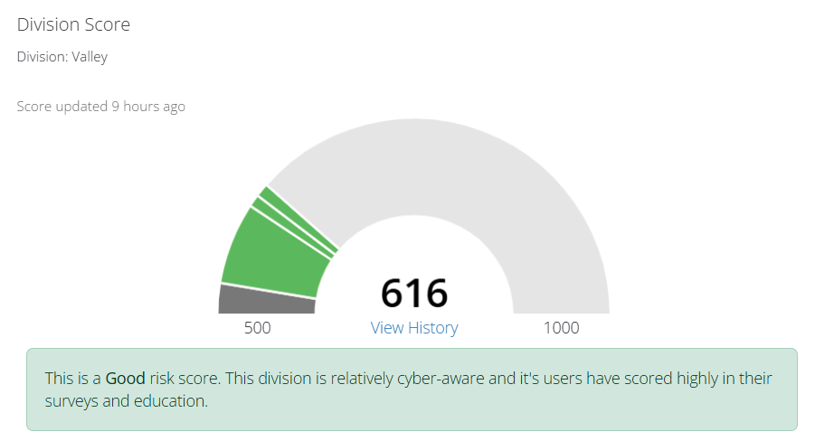
Beauceron is our Cyber Awareness and monitoring platform. 613 is good risk core which indicates that the company is relatively cyber-aware and it’s users have scored highly in the survey and education.



Risk Report: 


- Coalition Control is a tool that scans the public facing internet services pertaining to valleycreditunion.com.
- Most recent scan: 6 days ago

